EIPBN 2025 Micrograph Contest Entry Form
Micrograph Title: ___________________________________________
Description of image: (the more the better)

Magnification for (3"x4" image): ______________
Instrument(Make and Model): _______________________________
Imaging Microscope Type: Electron ___, Ion ___, Photon ___, Scan Probe ___
Submitted by: ______________________________________________________
Affiliation: ___________________________________________________________
Agreement: The International Conference on Electron, Ion and Photon Beam Technology and Nanofabrication has my permission to publish the submitted micrograph in its proceedings and for other promotional uses.
Signed:_________ ___________________________
By typing in your name in the line above you agree to the conditions in the Agreement. Of course you could also scan in your signature and place it there.
If you have multiple entries combine all slides into a single file.
Name your file: LastName-Institute.ppt (example: Randall-ZyvexLabs.ppt)
Also for multiple entries have all entry forms in a single file with one page per entry.
Name this word file: EForm-LastName-Institute.doc
Regards,
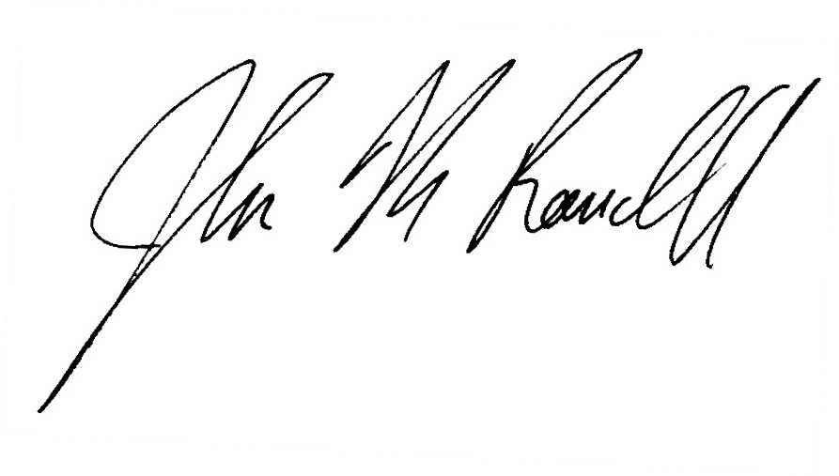
John N. Randall
CEO Zyvex Labs

